Title | Loan Growth Model @ Loan Projection
Department | Strategic Planning

No. | Name | Date | Activity
1. | Muhammad Syahid Bin Abd Halid | 22/8/2023 | Create Documentation
2. | Muhammad Syahid Bin Abd Halid | 28/8/2023 | Update (Budget)

EXECUTIVE SUMMARY

Background
Table below shows EXIM Bank’s Loan, Advances & Financing (LAF, RM’000) and Y-o-Y Growth throughout 2008 until 2022:

Year | LAF (RM’000) | Y-o-Y LAF |  | Year | LAF (RM’000) | Y-o-Y LAF
2008 | 1,925,325.00 | 0.00% |  | 2016 | 13,113,129.00 | 7.35%
2009 | 2,378,090.00 | 23.52% |  | 2017 | 11,709,044.00 | -10.71%
2010 | 2,071,481.00 | -12.89% |  | 2018 | 10,215,188.00 | -12.76%
2011 | 2,461,820.00 | 18.84% |  | 2019 | 6,778,920.00 | -33.64%
2012 | 3,659,240.00 | 48.64% |  | 2020 | 5,704,223.00 | -15.85%
2013 | 5,834,086.00 | 59.43% |  | 2021 | 5,268,867.00 | -7.63%
2014 | 8,260,354.00 | 41.59% |  | 2022 | 4,681,502.00 | -11.15%
2015 | 12,215,867.00 | 47.89%

Figure below shows EXIM Bank’s Loan, Advances & Financing (LAF, RM’000) and Y-o-Y Growth throughout 2008 until 2022:

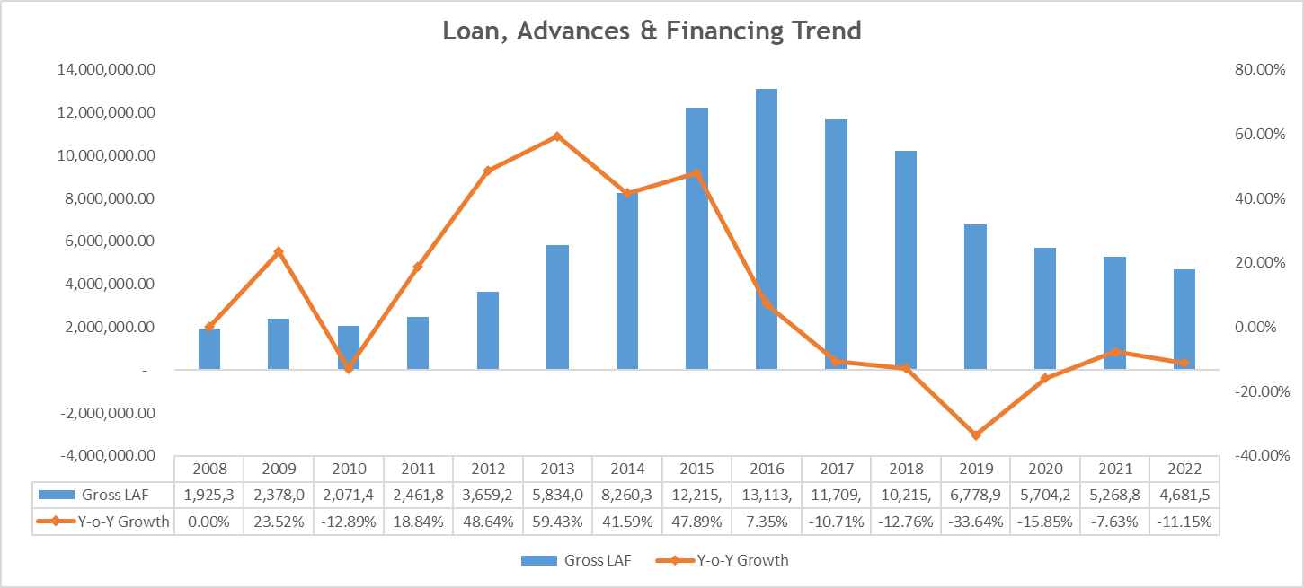

Using Statistical and Mathematical method we want to obtain as per below:

- What Macroeconomics variable impact most in the loan growth.
- What is the benchmark of the growth.
- What is expected until 2026.

Detailed
After carefully examining the trend of LAF in the figure above, it shows the growth of LAF is non-linear thus the most accurate best fit line to project the LAF growth would be a non-2-D model assuming the macroeconomics parameter are the variable for the LAF growth model.

- Macroeconomics Parameter

- USD Fed (Actual)
- FX (1 USD)
- OPR (Bank Negara)
- GDP (Constant LCU)
- KLSE Index @ FTSE Bursa MY KLCI Index

- Coefficient Correlation

 | LAF | USD Fed | FX | OPR | GDP | KLSE Index
LAF | 1.00
USD Fed | 0.20 | 1.00
FX | 0.69 | 0.56 | 1.00
OPR | 0.34 | 0.17 | -0.10 | 1.00
GDP | 0.52 | 0.67 | 0.82 | -0.15 | 1.00
KLSE Index | 0.58 | 0.07 | 0.17 | 0.12 | 0.43 | 1.00

Interpretation: All the parameters are positively correlated with the LAF growth and FX shows the most correlation with 0.69 bps.

- Granger Causality Test

H0: The Macroeconomics Parameter, does NOT Granger cause LAF. Assuming a significance level of 0.05, if the p-value is lesser than 0.05 then we do NOT reject the null hypothesis that X does NOT granger cause Y.

- USD Fed (Actual)

 | LAF, X | USD Fed, X
LAF, Y | 1.0 | 0.0005
USD Fed, Y | 0.0 | 1.0000

Interpretation: When X = USD Fed and Y = LAF is 0.0005, we reject the null hypothesis and conclude that X granger caused Y.

- FX (1 USD)

 | LAF, X | FX, X
LAF, Y | 1.0000 | 0.0017
FX, Y | 0.2165 | 1.0000

Interpretation: When X = FX and Y = LAF is 0.0017, we reject the null hypothesis and conclude that X granger caused Y.

- OPR (Bank Negara)

 | LAF, X | OPR, X
LAF, Y | 1.000 | 0.1824
OPR, Y | 0.005 | 1.000

Interpretation: When X = OPR and Y = LAF is 0.1823, we accept the null hypothesis and conclude that X does not granger cause Y.

- GDP (Constant LCU)

 | LAF, X | GDP, X
LAF, Y | 1.0000 | 0.0791
GDP, Y | 0.0014 | 0.9998

Interpretation: When X = GDP and Y = LAF is 0.0791, we accept the null hypothesis and conclude that X does not granger cause Y.

- KLSE Index @ FTSE Bursa MY KLCI Index

 | LAF, X | KLSE Index, X
LAF, Y | 1.0000 | 0.001
KLSE Index, Y | 0.0063 | 1.000

Interpretation: When X = KLSE Index and Y = LAF is 0.001, we reject the null hypothesis and conclude that X granger caused Y.

In conclusion, USD Fed, FX and KLSE Index will likely predict LAF Growth.

- Multiple Linear Regression

Formula:
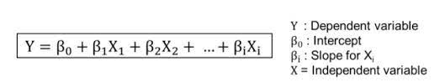

Model 1: USD Fed, FX and KLSE Index
Model 2: All Macroeconomics

- Regression Statistics

Model | M1 | M2
Multiple R | 0.86 | 0.97
R Square | 0.74 | 0.95
Adjusted R Square | 0.67 | 0.92
Standard Error | 2,202,197.46 | 1,082,967.27
Observations | 15.00 | 15.00

Interpretation: Though both Multiple R show a high predictive power against the macroeconomics parameter, Model 1 is slightly lower with 0.86 bps while Model 2 with 0.97 bps.

- ANOVA

Model 1 | df | SS | MS | F | Significance F
Regression | 3.00 | 154,877,626,251,978.00 | 51,625,875,417,325.90 | 10.65 | 0.001
Residual | 11.00 | 53,346,410,186,419.40 | 4,849,673,653,310.85
Total | 14.00 | 208,224,036,438,397.00

Model 2 | df | SS | MS | F | Significance F
Regression | 5.00 | 197,668,673,443,633.00 | 39,533,734,688,726.50 | 33.71 | 0.00001
Residual | 9.00 | 10,555,362,994,764.20 | 1,172,818,110,529.36
Total | 14.00 | 208,224,036,438,397.00

Interpretation: Significance F indicates low chance of random occurrence or false to the model with the macroeconomics parameter for both model by value less than 0.15 bps.

- Confidence Level

Model 1 | Coefficients | Standard Error | t Stat | P-value | Lower 95% | Upper 95%
Intercept | -26,436,321.08 | 5,917,316.59 | -4.47 | 0.00 | -39,460,247.09 | - 13,412,395.07
USD Fed | -819,670.28 | 586,411.36 | -1.40 | 0.19 | -2,110,352.98 | 471,012.42
FX | 5,761,794.29 | 1,418,297.98 | 4.06 | 0.00 | 2,640,141.48 | 8,883,447.11
KLSE Index | 7,522.07 | 2,488.00 | 3.02 | 0.01 | 2,046.02 | 12,998.12

Model 2 | Coefficients | Standard Error | t Stat | P-value | Lower 95% | Upper 95%
Intercept | -37,629,151.27 | 3,506,908.13 | -10.73 | 0.00 | -45,562,328.61 | - 29,695,973.94
USD Fed | -742,022.69 | 393,693.38 | -1.88 | 0.09 | -1,632,618.99 | 148,573.61
FX | 8,681,824.99 | 1,119,157.75 | 7.76 | 0.00 | 6,150,114.28 | 11,213,535.70
OPR | 2,584,488.54 | 657,529.04 | 3.93 | 0.00 | 1,097,054.52 | 4,071,922.57
GDP | -0.00 | 0.00 | -2.19 | 0.06 | -0.00 | 0.00
KLSE Index | 8,989.63 | 1,688.34 | 5.32 | 0.00 | 5,170.34 | 12,808.93

Interpretation: P-value indicates all the parameters have a high predictive power with the macroeconomics parameter by value less than 0.15 bps.

Equation Model 1:

$$y=-26,436,321.08-819,670.28x_{1}+5,761,794.29x_{2}+7,522.07x_{3}$$

Equation Model 2:

$$y=-37,629,151.27-742,022.69x_{1}+8,681,824.99x_{2}+2,584,488.54x_{3}+8,989.63x_{5}$$

- Error Rate Model 1

Year | LAF Actual (RM’000) | LAF Projection (RM’000) | A. Growth | P. Growth | Error Rate
2008 | 1,925,325.00 | -87,411.41 | 0.00% | 0.00% | -104.5%
2009 | 2,378,090.00 | 2,663,961.72 | 23.52% | -3147.61% | 12.0%
2010 | 2,071,481.00 | 2,550,596.09 | -12.89% | -4.26% | 23.1%
2011 | 2,461,820.00 | 3,178,234.69 | 18.84% | 24.61% | 29.1%
2012 | 3,659,240.00 | 3,684,451.07 | 48.64% | 15.93% | 0.7%
2013 | 5,834,086.00 | 6,309,486.61 | 59.43% | 71.25% | 8.1%
2014 | 8,260,354.00 | 6,744,472.04 | 41.59% | 6.89% | -18.4%
2015 | 12,215,867.00 | 10,614,637.67 | 47.89% | 57.38% | -13.1%
2016 | 13,113,129.00 | 11,145,537.66 | 7.35% | 5.00% | -15.0%
2017 | 11,709,044.00 | 9,254,306.24 | -10.71% | -16.97% | -21.0%
2018 | 10,215,188.00 | 8,076,344.10 | -12.76% | -12.73% | -20.9%
2019 | 6,778,920.00 | 7,660,157.46 | -33.64% | -5.15% | 13.0%
2020 | 5,704,223.00 | 8,720,823.69 | -15.85% | 13.85% | 52.9%
2021 | 5,268,867.00 | 9,211,079.23 | -7.63% | 5.62% | 74.8%
2022 | 4,681,502.00 | 6,550,459.13 | -11.15% | -28.88% | 39.9%
Max | 13,113,129.00 | 11,145,537.66 | 59.43% | 71.25% | 74.82%
Min | 1,925,325.00 | -87,411.41 | -33.64% | -3147.61% | -104.54%
Average | 6,418,475.73 | 6,418,475.73 | 9.51% | -201.01% | 4.05%

- Error Rate Model 2

Year | LAF Actual (RM’000) | LAF Projection (RM’000) | A. Growth | P. Growth | Error Rate
2008 | 1,925,325.00 | 1,576,167.77 | 0.00% | 0.00% | -18.1%
2009 | 2,378,090.00 | 1,668,195.87 | 23.52% | 5.84% | -29.9%
2010 | 2,071,481.00 | 2,349,418.63 | -12.89% | 40.84% | 13.4%
2011 | 2,461,820.00 | 3,523,487.03 | 18.84% | 49.97% | 43.1%
2012 | 3,659,240.00 | 3,490,653.74 | 48.64% | -0.93% | -4.6%
2013 | 5,834,086.00 | 6,644,602.82 | 59.43% | 90.35% | 13.9%
2014 | 8,260,354.00 | 7,679,410.45 | 41.59% | 15.57% | -7.0%
2015 | 12,215,867.00 | 13,332,984.79 | 47.89% | 73.62% | 9.1%
2016 | 13,113,129.00 | 13,304,455.70 | 7.35% | -0.21% | 1.5%
2017 | 11,709,044.00 | 9,881,512.58 | -10.71% | -25.73% | -15.6%
2018 | 10,215,188.00 | 8,983,953.79 | -12.76% | -9.08% | -12.1%
2019 | 6,778,920.00 | 7,091,612.25 | -33.64% | -21.06% | 4.6%
2020 | 5,704,223.00 | 5,268,537.74 | -15.85% | -25.71% | -7.6%
2021 | 5,268,867.00 | 5,809,885.53 | -7.63% | 10.28% | 10.3%
2022 | 4,681,502.00 | 5,672,257.32 | -11.15% | -2.37% | 21.2%
Max | 13,113,129.00 | 13,332,984.79 | 59.43% | 90.35% | 43.13%
Min | 1,925,325.00 | 1,576,167.77 | -33.64% | -25.73% | -29.85%
Average | 6,418,475.73 | 6,418,475.73 | 9.51% | 13.42% | 1.48%

Using the Regression Model, figure below shows the LAF Actual against the projection from 2008 until 2022 (RM’000) for both models:

Model 1:

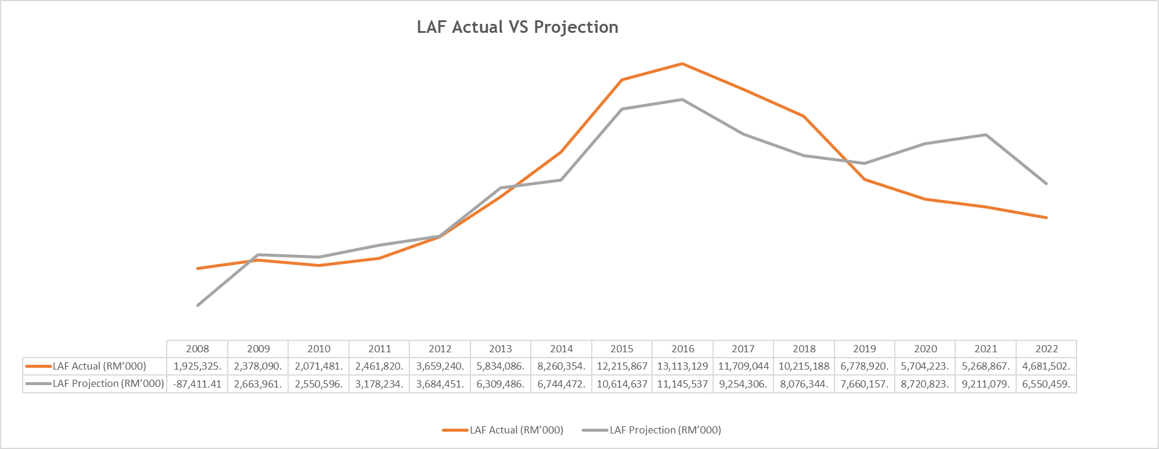

Model 2:

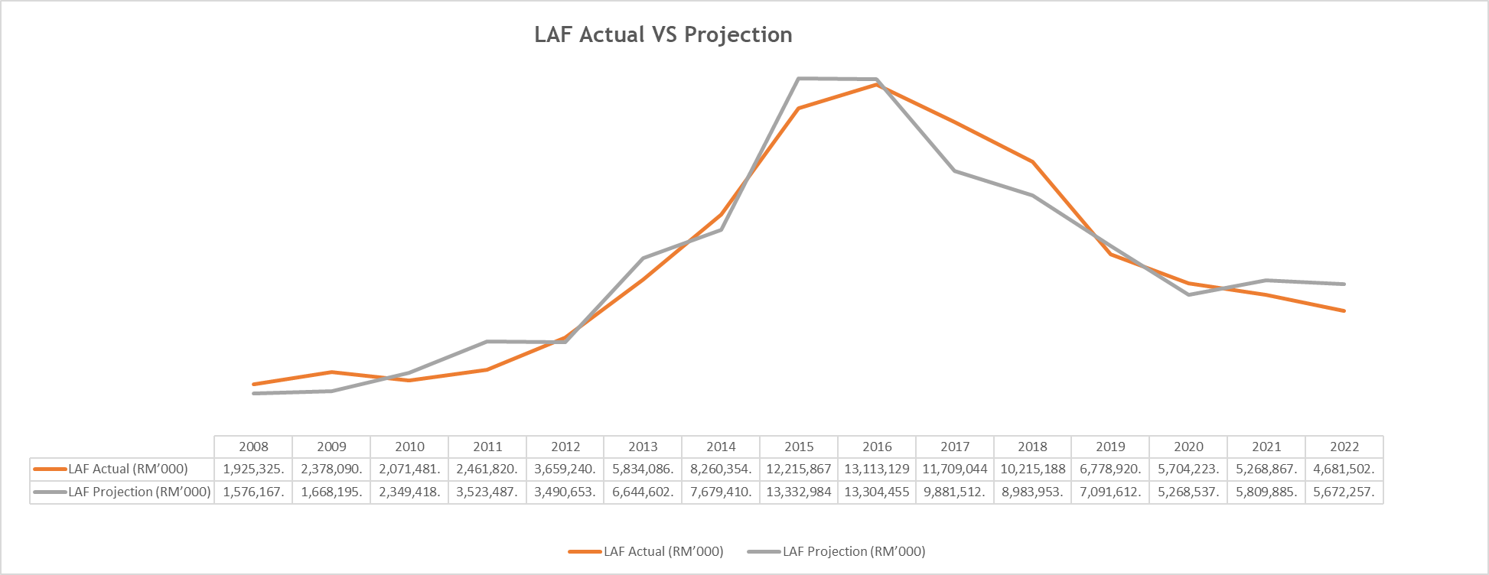

- Findings

Projection | Model 1 | Model 2
Standard Deviation | 2,202,197.46 | 1,082,967.27
Observation | 15.00 | 15.00
MSE | 568,604.94 | 279,620.95
Mean | 6,418,475.73 | 6,418,475.73
Multiple R | 0.86 | 0.97
Compounded Annual Growth Rate | -233.35% | 8.91%

From the table above assumption as per below:

- Multiple R shows Model 2 has high predictive power with the macroeconomics parameter with 0.97 bps compared to Model 1.

- MSE Model 2 shows a more accurate reflection towards the actual mean the with less spread out compared to Model 1.

- Conclusion
From the findings above, we conclude to use Model 2 due to higher predictive power as our Lower Limit while Model 1 as our Upper Limit.

- Though the most macroeconomics variable that gave impact to the loan growth is USD Fed, FX and KLSE Index, OPR and GDP also will likely predict LAF Growth as well.

- The benchmark of the targeted growth:

Model | Amount (’000)
1 | +RM2,202,197.46
2 | +RM1,082,967.27

- What is expected growth until 2026.

- Aspiration

Year | Model 1 | Model 2 | Growth (M.1) | Growth (M.2)
2022 | 4,681,502.00 | 4,681,502.00 | -11.15% | -11.15%
2023 | 6,851,123.00 | 6,851,123.00 | 46.34% | 46.34%
2024 | 9,053,320.46 | 7,934,090.27 | 32.14% | 15.81%
2025 | 11,255,517.92 | 9,017,057.54 | 24.32% | 13.65%
2026 | 13,457,715.38 | 10,100,024.81 | 19.57% | 12.01%

- Moderate

Year | Model 1 | Model 2 | Growth (M.1) | Growth (M.2)
2022 | 4,681,503.00 | 4,681,503.00 | -11.15% | -11.15%
2023 | 5,674,286.00 | 5,674,286.00 | 21.21% | 21.21%
2024 | 7,876,483.46 | 6,757,253.27 | 38.81% | 19.09%
2025 | 10,078,680.92 | 7,840,220.54 | 27.96% | 16.03%
2026 | 12,280,878.38 | 8,923,187.81 | 21.85% | 13.81%

- Review

Year | Model 1 | Model 2 | Growth (M.1) | Growth (M.2)
2022 | 4,681,504.00 | 4,681,504.00 | -11.15% | -11.15%
2023 | 5,335,153.00 | 5,335,153.00 | 13.96% | 13.96%
2024 | 7,537,350.46 | 6,418,120.27 | 41.28% | 20.30%
2025 | 9,739,547.92 | 7,501,087.54 | 29.22% | 16.87%
2026 | 11,941,745.38 | 8,584,054.81 | 22.61% | 14.44%

Using the Regression Model, figure below shows the LAF projection for Aspiration, Moderate & Review on Model 1 and Model 2 until 2026 (RM’000):



